*Hospital Management Dataset*

*Analysis*

***Wireframe Documentation***

**By**

***AMAN RAJBHAR***

# Homepage

***we have divided analysis into three Pages: -***

**Page 2 Hospital Overview and Ratings:** 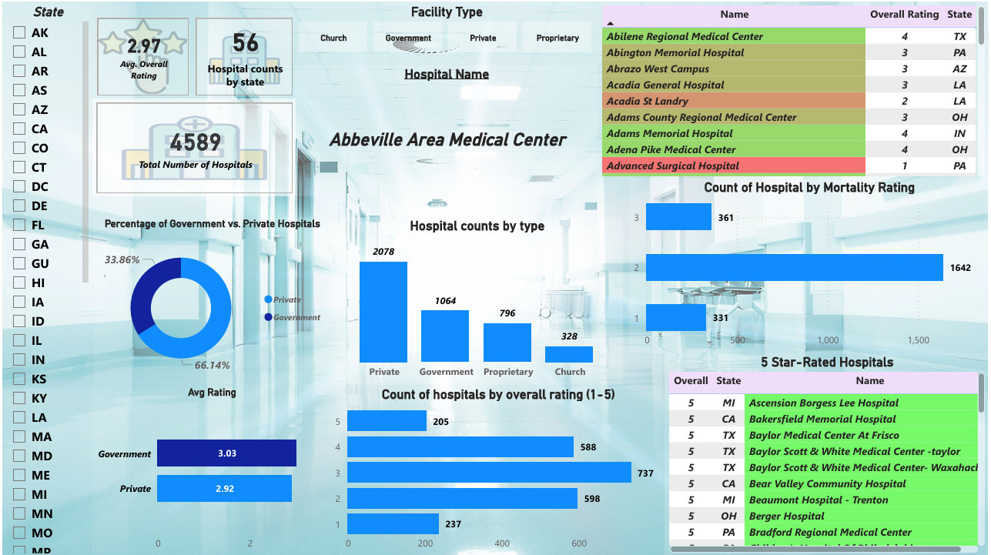

*In this section we designed our first dashboard and tried to interpret the followings:*

**KPI Cards**:

* **Font Size**: Large for easy visibility.
* **Layout**: Displayed in a horizontal row at the top for quick access to key metrics.

**Filters (State Selection)**:

* **Type**: Vertical filter option on the left sidebar.
* **Purpose**: Dynamic filtering of all charts and tables based on the selected state.

**Tables**:

* **Purpose**: Tables are used to show detailed data, such as hospital names, ratings, and states.
* **Interaction**: Scrollable, with the ability to sort columns for easier data navigation.

**Pie Chart**:

* **Purpose**: Provides a high-level view of the distribution of hospitals by ownership type.
* **Interaction**: May allow users to drill down by clicking on sections to filter other dashboard elements by hospital type.

**Bar Charts**:

* **Purpose**: Used for clear comparisons across categories, such as hospital counts by type, overall ratings, or mortality ratings.
* **Interaction**: Bars can be clicked to filter other visuals and data tables.

**Color Coding**:

* **Hospital Ratings**: Different colors are used to highlight hospitals with varying ratings, improving visual clarity.

***Key Features:***

**Interactivity**:

* The dashboard allows users to filter data by state and drill down into specific details.
* Bar charts and pie charts are interactive, allowing for a deeper exploration of the dataset.

**Visual Clarity**:

* The use of KPI cards provides immediate insights into key metrics such as the total number of hospitals and average ratings.
* The combination of bar charts and pie charts makes it easy to compare different metrics like hospital type distribution and overall ratings.

**Tables for Detailed Insights**:

* Tables are used to display a large volume of data in a structured format. This is especially helpful for displaying hospital names and ratings in a way that can be sorted or filtered.

**Page 2: Cost vs. Quality for Procedures**

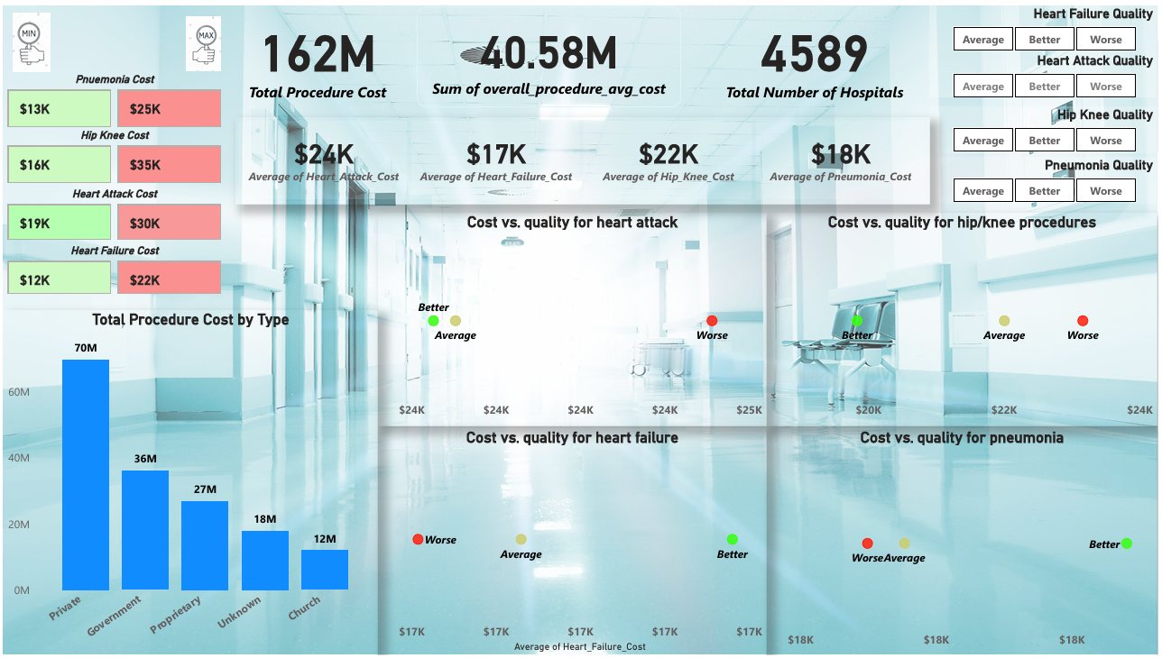

**KPI Cards**:

* **Purpose**: Displays essential numeric data, allowing users to quickly gauge key metrics.
* **Interaction**: Static, showing summary data for quick interpretation.

**Procedure Cost Min/Max Values**:

* **Purpose**: A set of stacked boxes on the left that provides users with quick access to minimum and maximum costs for specific conditions.
* **Interaction**: Static, purely informational.

**Bar Chart - Total Procedure Cost by Type**:

* **Purpose**: A bar chart providing a visual comparison of total procedure costs by hospital type (e.g., Private, Government, Church).
* **Interaction**: Can be interactive, allowing users to click on bars and drill down into specific types of procedures.

**Scatter Plots (Cost vs. Quality)**:

* **Purpose**: Scatter plots illustrate the relationship between average costs and quality for each medical condition (heart attack, heart failure, etc.).
* **Interaction**: Plots may allow zooming in or filtering based on cost ranges, or hover functionality for more detailed data on each plotted point.

**Quality Indicator Buttons**:

* **Purpose**: These buttons allow users to filter the scatter plots based on the quality rating for each condition (heart attack, heart failure, etc.).
* **Interaction**: Clicking a quality level filters the scatter plots, updating them with corresponding data points (e.g., only showing hospitals with “Better” outcomes).

***Key Features:***

**Visual Summary**:

* KPI cards at the top provide an immediate snapshot of total and average costs, ensuring quick access to critical information.

**Interactive Cost and Quality Comparisons**:

* Scatter plots present a visual comparison between procedure costs and the corresponding quality of care, providing users with insights into how spending relates to health outcomes.

**Cost Distribution for Different Conditions**:

* Bar and scatter plots offer a clear distribution of procedure costs for specific conditions and hospital types, making it easy for users to identify trends.

**State Selection Filters**:

* While not explicitly shown, this dashboard could benefit from having a state or hospital type filter (e.g., private, government), allowing users to narrow down results based on regional or ownership criteria.

**Page 3: Performance and Quality Insights :**

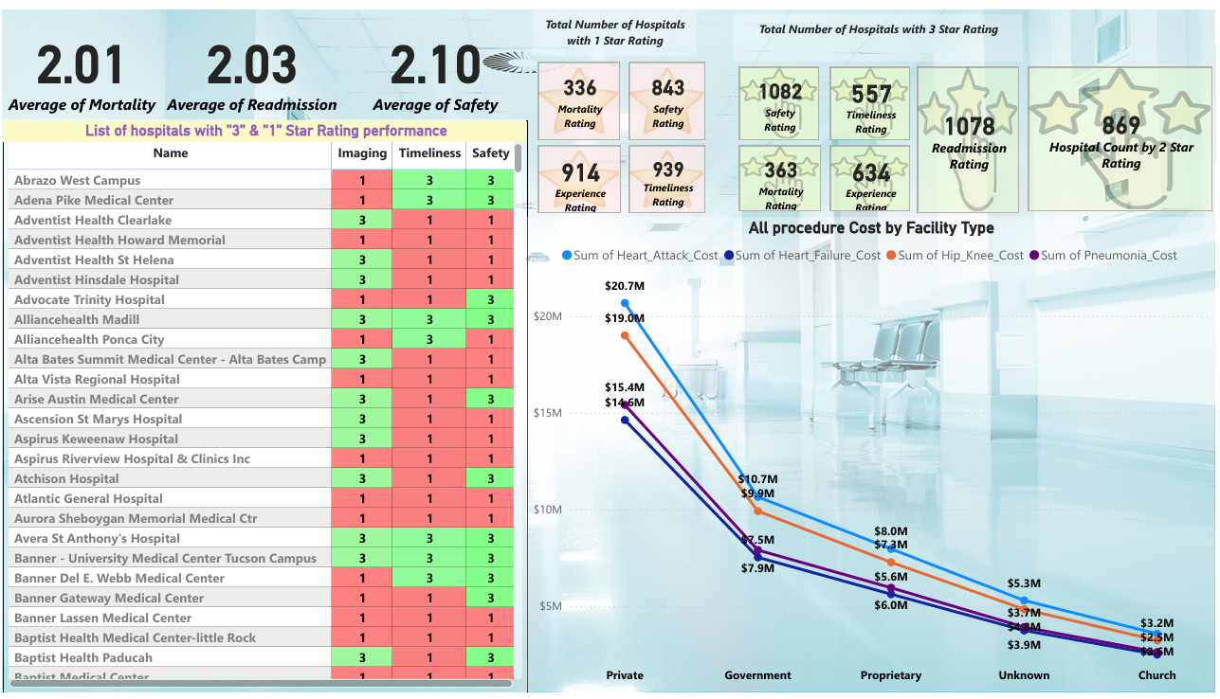

* **KPI cards** at the top offer a clear snapshot of average hospital performance in mortality, readmission, and safety.
* **Hospital List** on the left provides a performance breakdown for specific hospitals based on their ratings in imaging, timeliness, and safety.
* **Procedure Costs by Facility Type** (line graph) in the lower-right shows a visual comparison of total costs for heart attacks, heart failure, hip/knee procedures, and pneumonia, segmented by facility ownership type.
* **Ratings Overview**: Boxes summarizing the number of hospitals with 1-star or 3-star ratings across different quality measures such as mortality, safety, timeliness, and readmission.

***Key Features:***

* **KPI Cards:** Display Average statistics of mortality, readmission, and safety ratings.
* **Interactive Potential:** The line graph showing procedure costs could allow users to hover over lines for more detailed cost breakdowns or toggle specific conditions to isolate certain cost categories.
* **Color-Coded Ratings Table:** Red (1-star) and green (3-star) provide an intuitive way to quickly identify hospital performance.
* **Cost Comparisons:** The graph provides insight into the varying costs across facility types for the most common procedures.